**Московский авиационный институт**

**(Национальный исследовательский университет)**

Институт: «Информационные технологии и прикладная математика»

Кафедра: 806 «Вычислительная математика и программирование»

Дисциплина: «Компьютерная графика»

**Лабораторная работа № 4**

Тема: Ознакомление с технологией OpenGL

Студент: Лошманов Юрий Андреевич

Группа: 80-306

Преподаватель: Чернышов Л.Н.

Дата:

Оценка:

Москва, 2021

1. **Постановка задачи**

Создать графическое приложение с использованием OpenGL. Изобразить заданное тело с использованием средств OpenGL 2.1 (или выше).

Использовать буфер вершин. Точность аппроксимации тела задается пользователем. Обеспечить возможность вращения и масштабирования многогранника и удаление невидимых линий и поверхностей.

Реализовать простую модель освещения на GLSL. Параметры освещения и отражающие свойства материала задаются пользователем в диалоговом режиме.

1. **Описание программы**

Программа состоит из окна для взаимодействия с многогранником, из сочетаний клавиш для вращения многогранника и изменения некоторых его параметров.

1. **Набор тестов**

1. Изначальный вид.

2. Вращение многогранника.

3. Увеличение точности аппроксимации.

4. Увеличение коэффициента диффузного отражения рассеянного света.

5. Увеличение коэффициента диффузного отражения падающего света.

1. **Результаты выполнения тестов**

1. Изначальный вид.  
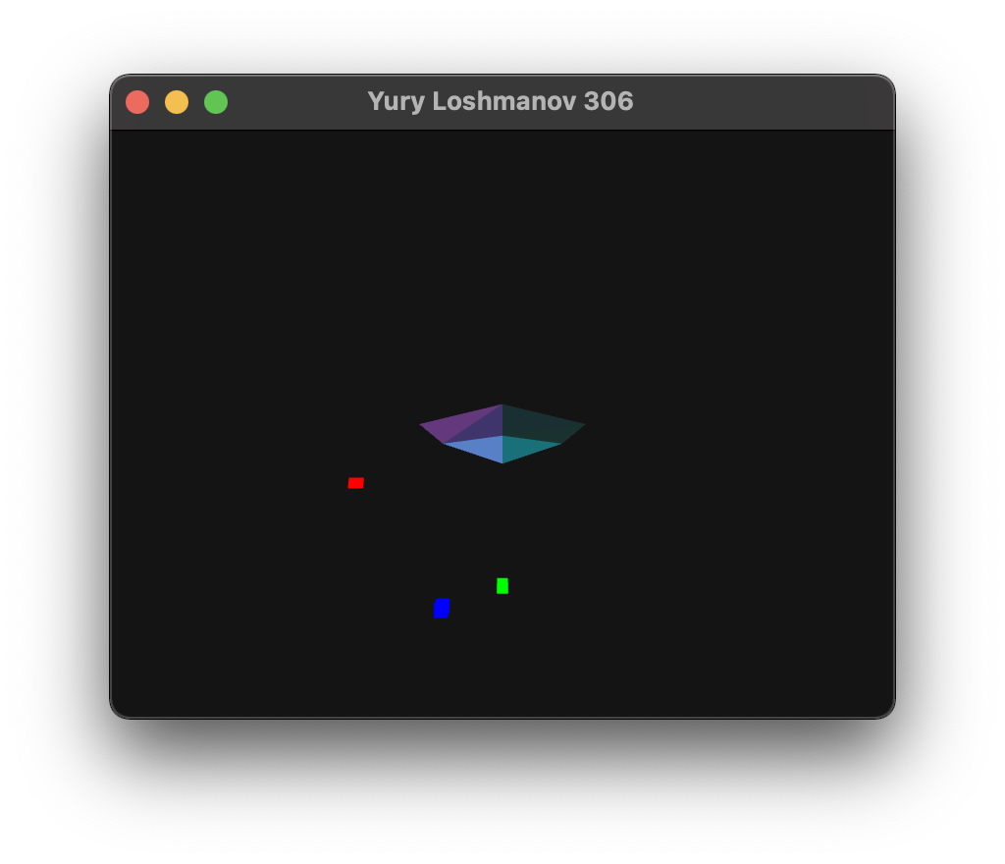

Рис. 4.1 Результат открытия окна

2. Вращение многогранника.

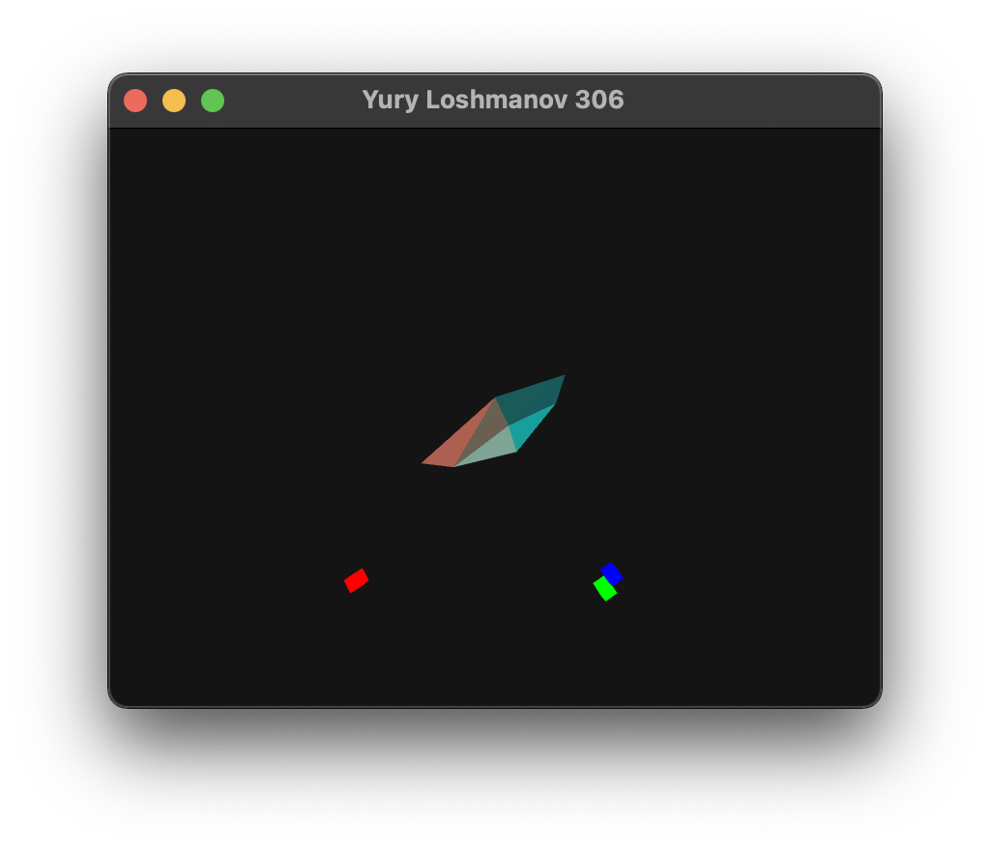

Рис. 4.2 Результат вращения многогранника

3. Увеличение точности аппроксимации.

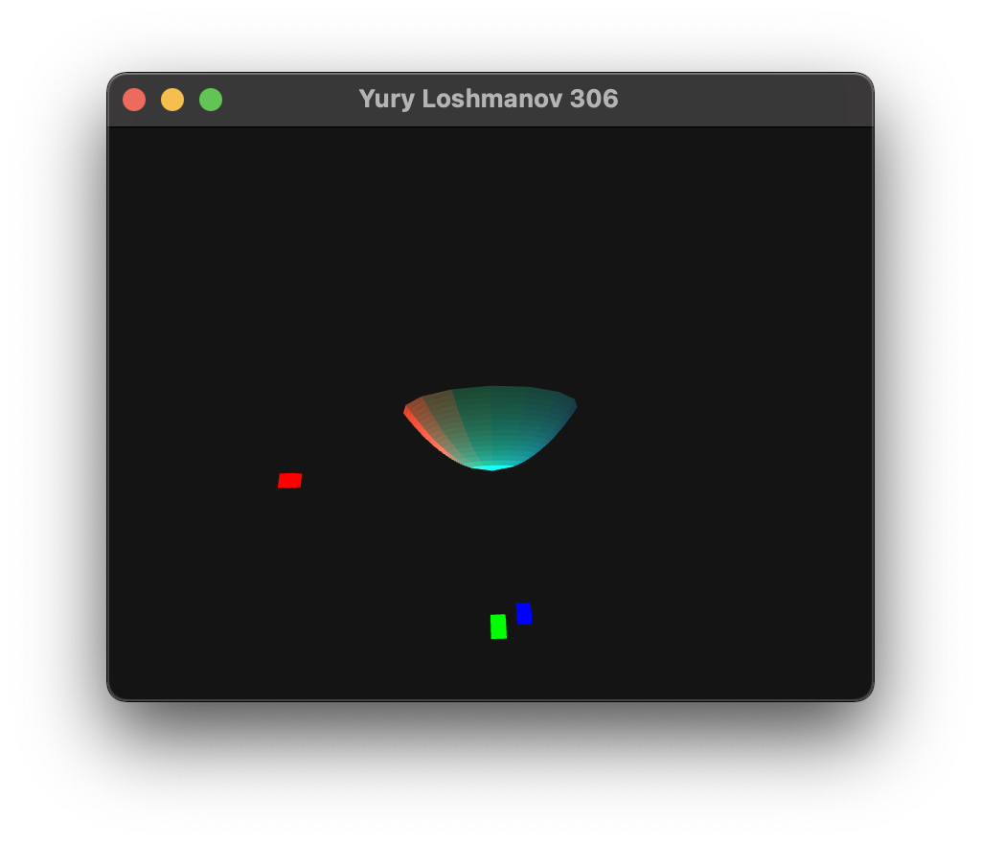

Рис. 4.3 Результат увеличения точности аппроксимации

4. Уменьшение коэффициента диффузного отражения рассеянного света.

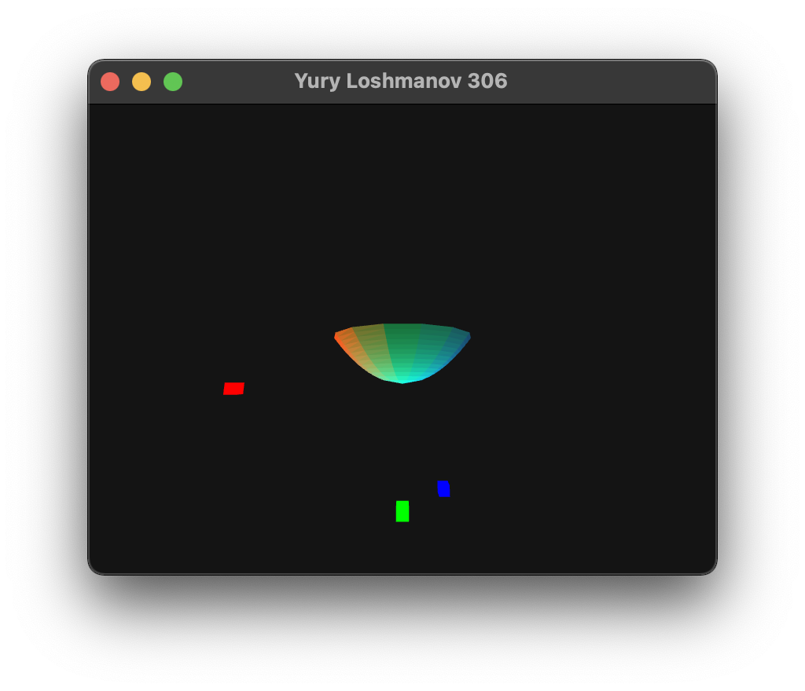

Рис. 4.4 Результат уменьшения коэффициента диффузного отражения рассеянного света

5. Увеличение коэффициента диффузного отражения падающего света.

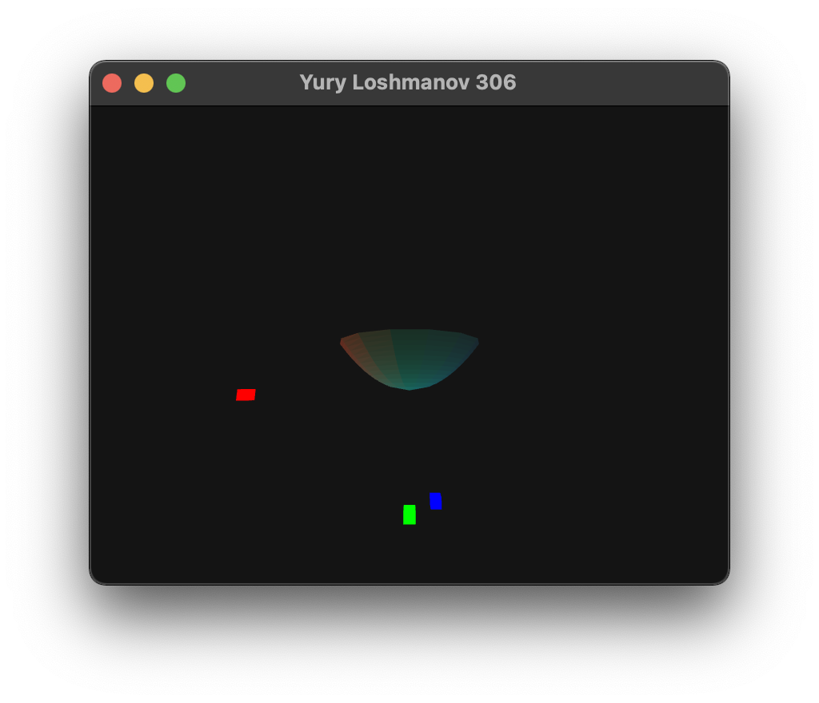

Рис. 4.5 Результат увеличения коэффициента диффузного падающего света

1. **Листинг программы**

**main.cpp**

//

// Yury Loshmanov

// 306

//

#include <iostream>

#include <fstream>

#include <vector>

#include <cmath>

#include <glad/glad.h>

#include <GLFW/glfw3.h>

#include <glm/glm.hpp>

#include <glm/gtc/matrix_transform.hpp>

#include <glm/gtc/type_ptr.hpp>

#include "math_help.hpp"

void key_callback(GLFWwindow *window, int key, int scancode, int action, int mode);

void framebuffer_size_callback(GLFWwindow *window, int width, int height);

std::vector<char> shader_source_code(const std::string &filename);

GLuint createShader(GLuint shaderType, const std::string &file);

GLuint attachAndLinkShaders(GLuint vertexShader, GLuint fragmentShader);

std::pair<std::vector<float>, std::vector<unsigned>> customFigure(size_t precision);

std::pair<std::vector<float>, std::vector<unsigned>> cubeFigure();

const GLuint WIDTH = 800, HEIGHT = 600;

int figurePrecision = 2;

bool recalculateFigure = false;

float FOV = 45.0f;

float RotateX = 0.0f;

float RotateY = 0.0f;

float RotateZ = 0.0f;

glm::vec3 cameraPos = glm::vec3(4.0f, 0.0f, 4.0f);

glm::vec3 cameraFront = glm::vec3(-1.0f, 0.0f, -1.0f);

glm::vec3 cameraUp = glm::vec3(0.0f, 0.0f, 1.0f);

glm::vec3 lightPos(2.0f, 0.0f, 0.5f);

float ambientStrength = 0.3;

float diffuseStrength = 0.7;

float specularStrength = 0.9;

int specularPow = 32;

int main() {

glfwInit();

glfwWindowHint(GLFW_CONTEXT_VERSION_MAJOR, 3);

glfwWindowHint(GLFW_CONTEXT_VERSION_MINOR, 3);

glfwWindowHint(GLFW_OPENGL_FORWARD_COMPAT, GL_TRUE); // To make MacOS happy; should not be needed

glfwWindowHint(GLFW_OPENGL_PROFILE, GLFW_OPENGL_CORE_PROFILE);

glfwWindowHint(GLFW_RESIZABLE, GL_TRUE);

GLFWwindow *window = glfwCreateWindow(WIDTH, HEIGHT, "LearnOpenGL", NULL, NULL);

glfwMakeContextCurrent(window);

if (window == NULL) {

std::cout << "Failed to create GLFW window" << std::endl;

glfwTerminate();

return EXIT_FAILURE;

}

glfwSetKeyCallback(window, key_callback);

glfwSetFramebufferSizeCallback(window, framebuffer_size_callback);

if (!gladLoadGLLoader((GLADloadproc) glfwGetProcAddress)) {

std::cout << "Failed to initialize OpenGL context" << std::endl;

return EXIT_FAILURE;

}

auto tempTriangles = customFigure(figurePrecision);

std::vector<float> vertices = tempTriangles.first;

std::vector<unsigned> indices = tempTriangles.second;

auto tempCubeTriangles = cubeFigure();

std::vector<float> cubeVertices = tempCubeTriangles.first;

std::vector<unsigned> cubeIndices = tempCubeTriangles.second;

GLuint vertexShader = createShader(GL_VERTEX_SHADER, "../shaders/shader.vert");

GLuint fragmentShader = createShader(GL_FRAGMENT_SHADER, "../shaders/shader.frag");

GLuint shaderProgram = attachAndLinkShaders(vertexShader, fragmentShader);

glDeleteShader(vertexShader);

glDeleteShader(fragmentShader);

GLuint lightVertexShader = createShader(GL_VERTEX_SHADER, "../shaders/lightShader.vert");

GLuint lightFragmentShader = createShader(GL_FRAGMENT_SHADER, "../shaders/lightShader.frag");

GLuint lightShaderProgram = attachAndLinkShaders(lightVertexShader, lightFragmentShader);

glDeleteShader(lightVertexShader);

glDeleteShader(lightFragmentShader);

std::cout << "--- SHADERS INITIALIZED ---\n";

GLuint VAO1, VBO1, EBO1;

glGenVertexArrays(1, &VAO1);

glBindVertexArray(VAO1);

glGenBuffers(1, &VBO1);

glGenBuffers(1, &EBO1);

glBindBuffer(GL_ARRAY_BUFFER, VBO1);

glBufferData(GL_ARRAY_BUFFER, vertices.size() * sizeof(float), vertices.data(), GL_DYNAMIC_DRAW);

glBindBuffer(GL_ELEMENT_ARRAY_BUFFER, EBO1);

glBufferData(GL_ELEMENT_ARRAY_BUFFER, indices.size() * sizeof(unsigned), indices.data(), GL_DYNAMIC_DRAW);

glVertexAttribPointer(0, 3, GL_FLOAT, GL_FALSE, 9 * sizeof(float), (void *) 0);

glEnableVertexAttribArray(0);

glVertexAttribPointer(1, 3, GL_FLOAT, GL_FALSE, 9 * sizeof(float), (void *) (3 * sizeof(float)));

glEnableVertexAttribArray(1);

glVertexAttribPointer(2, 3, GL_FLOAT, GL_FALSE, 9 * sizeof(float), (void *) (6 * sizeof(float)));

glEnableVertexAttribArray(2);

GLuint lightVAO, lightVBO, lightEBO;

glGenVertexArrays(1, &lightVAO);

glBindVertexArray(lightVAO);

glGenBuffers(1, &lightVBO);

glGenBuffers(1, &lightEBO);

glBindBuffer(GL_ARRAY_BUFFER, lightVBO);

glBufferData(GL_ARRAY_BUFFER, cubeVertices.size() * sizeof(float), cubeVertices.data(), GL_STATIC_DRAW);

glBindBuffer(GL_ELEMENT_ARRAY_BUFFER, lightEBO);

glBufferData(GL_ELEMENT_ARRAY_BUFFER, cubeIndices.size() * sizeof(unsigned), cubeIndices.data(), GL_STATIC_DRAW);

glVertexAttribPointer(0, 3, GL_FLOAT, GL_FALSE, 3 * sizeof(float), (void *) 0);

glEnableVertexAttribArray(0);

glUseProgram(shaderProgram);

glCullFace(GL_CW);

glEnable(GL_CULL_FACE);

//glPolygonMode(GL_CCW, GL_LINE);

glEnable(GL_DEPTH_TEST);

glm::mat4 projection = glm::perspective(glm::radians(FOV), (float) WIDTH / (float) HEIGHT, 0.1f, 100.0f);

while (!glfwWindowShouldClose(window)) {

glClearColor(0.2f, 0.3f, 0.3f, 1.0f);

glClear(GL_COLOR_BUFFER_BIT | GL_DEPTH_BUFFER_BIT);

glBindVertexArray(VAO1);

glUseProgram(shaderProgram);

glUniform3f(glGetUniformLocation(shaderProgram, "lightColor"), 1.0f, 1.0f, 1.0f);

glUniform3f(glGetUniformLocation(shaderProgram, "lightPos"), lightPos.x, lightPos.y, lightPos.z);

glUniform1f(glGetUniformLocation(shaderProgram, "ambientStrength"), ambientStrength);

glUniform1f(glGetUniformLocation(shaderProgram, "diffuseStrength"), diffuseStrength);

glUniform1f(glGetUniformLocation(shaderProgram, "specularStrength"), specularStrength);

glUniform1i(glGetUniformLocation(shaderProgram, "specularPow"), specularPow);

if (recalculateFigure) {

tempTriangles = customFigure(figurePrecision);

vertices = tempTriangles.first;

indices = tempTriangles.second;

glad_glBufferData(VBO1, vertices.size() * sizeof(float), vertices.data(), GL_DYNAMIC_DRAW);

glad_glBufferData(EBO1, indices.size() * sizeof(unsigned), indices.data(), GL_DYNAMIC_DRAW);

recalculateFigure = false;

}

glm::mat4 model = glm::mat4(1.0f);

//model = glm::rotate(model, (float) glfwGetTime() / 2.0f, glm::vec3(0.0, 0.0, 1.0));

//model = glm::scale(model, glm::vec3(0.7, 0.5, 0.5));

glm::mat4 view = glm::mat4(1.0f);

view = glm::lookAt(cameraPos, cameraPos + cameraFront, cameraUp);

view = glm::rotate(view, glm::radians(RotateX), glm::vec3(1.0, 0.0, 0.0));

view = glm::rotate(view, glm::radians(RotateY), glm::vec3(0.0, 1.0, 0.0));

view = glm::rotate(view, glm::radians(RotateZ), glm::vec3(0.0, 0.0, 1.0));

glm::vec3 tempCameraPos = glm::vec3(glm::vec4(cameraPos, 1.0) * view);

glUniform3f(glGetUniformLocation(shaderProgram, "viewPos"), tempCameraPos.x, tempCameraPos.y, tempCameraPos.z);

glUniformMatrix4fv(glGetUniformLocation(shaderProgram, "model"), 1, GL_FALSE, glm::value_ptr(model));

glUniformMatrix4fv(glGetUniformLocation(shaderProgram, "view"), 1, GL_FALSE, glm::value_ptr(view));

glUniformMatrix4fv(glGetUniformLocation(shaderProgram, "projection"), 1, GL_FALSE, glm::value_ptr(projection));

glDrawElements(GL_TRIANGLES, indices.size(), GL_UNSIGNED_INT, 0);

glBindVertexArray(lightVAO);

glUseProgram(lightShaderProgram);

model = glm::mat4(1.0f);

model = glm::translate(model, lightPos);

model = glm::scale(model, glm::vec3(0.1f));

glUniformMatrix4fv(glGetUniformLocation(lightShaderProgram, "model"), 1, GL_FALSE, glm::value_ptr(model));

glUniformMatrix4fv(glGetUniformLocation(lightShaderProgram, "view"), 1, GL_FALSE, glm::value_ptr(view));

glUniformMatrix4fv(glGetUniformLocation(lightShaderProgram, "projection"), 1, GL_FALSE,

glm::value_ptr(projection));

glUniform3f(glGetUniformLocation(lightShaderProgram, "lightColor"), 1.0f, 1.0f, 1.0f);

glDrawElements(GL_TRIANGLES, cubeIndices.size(), GL_UNSIGNED_INT, 0);

glfwSwapBuffers(window);

glfwPollEvents();

}

glDeleteVertexArrays(1, &VAO1);

glDeleteBuffers(1, &VBO1);

glDeleteBuffers(1, &EBO1);

glDeleteProgram(shaderProgram);

glDeleteVertexArrays(1, &lightVAO);

glDeleteBuffers(1, &lightVBO);

glDeleteBuffers(1, &lightEBO);

glDeleteProgram(lightShaderProgram);

glfwTerminate();

return EXIT_SUCCESS;

}

void key_callback(GLFWwindow *window, int key, int scancode, int action, int mode) {

//std::cout << key << std::endl;

float lightSpeed = 0.3f;

float rotateSpeed = 3.0f;

if (glfwGetKey(window, GLFW_KEY_ESCAPE) == GLFW_PRESS) {

glfwSetWindowShouldClose(window, GL_TRUE);

} else if (glfwGetKey(window, GLFW_KEY_W) == GLFW_PRESS) {

lightPos.x -= lightSpeed;

} else if (glfwGetKey(window, GLFW_KEY_S) == GLFW_PRESS) {

lightPos.x += lightSpeed;

} else if (glfwGetKey(window, GLFW_KEY_A) == GLFW_PRESS) {

lightPos.y -= lightSpeed;

} else if (glfwGetKey(window, GLFW_KEY_D) == GLFW_PRESS) {

lightPos.y += lightSpeed;

} else if (glfwGetKey(window, GLFW_KEY_Q) == GLFW_PRESS) {

lightPos.z -= lightSpeed;

} else if (glfwGetKey(window, GLFW_KEY_E) == GLFW_PRESS) {

lightPos.z += lightSpeed;

} else if (glfwGetKey(window, GLFW_KEY_Z) == GLFW_PRESS) {

RotateZ += rotateSpeed;

} else if (glfwGetKey(window, GLFW_KEY_X) == GLFW_PRESS) {

RotateZ -= rotateSpeed;

} else if (glfwGetKey(window, GLFW_KEY_C) == GLFW_PRESS) {

RotateY += rotateSpeed;

} else if (glfwGetKey(window, GLFW_KEY_V) == GLFW_PRESS) {

RotateY -= rotateSpeed;

} else if (glfwGetKey(window, GLFW_KEY_C) == GLFW_PRESS) {

RotateX += rotateSpeed;

} else if (glfwGetKey(window, GLFW_KEY_V) == GLFW_PRESS) {

RotateX -= rotateSpeed;

} else if (glfwGetKey(window, GLFW_KEY_EQUAL) == GLFW_PRESS) {

figurePrecision++;

recalculateFigure = true;

} else if (glfwGetKey(window, GLFW_KEY_MINUS) == GLFW_PRESS) {

figurePrecision--;

recalculateFigure = true;

} else if (glfwGetKey(window, GLFW_KEY_F1) == GLFW_PRESS) {

ambientStrength = std::max(std::min(ambientStrength - 0.1f, 1.0f), 0.0f);

} else if (glfwGetKey(window, GLFW_KEY_F2) == GLFW_PRESS) {

ambientStrength = std::max(std::min(ambientStrength + 0.1f, 1.0f), 0.0f);

} else if (glfwGetKey(window, GLFW_KEY_F3) == GLFW_PRESS) {

diffuseStrength = std::max(std::min(diffuseStrength - 0.1f, 1.0f), 0.0f);

} else if (glfwGetKey(window, GLFW_KEY_F4) == GLFW_PRESS) {

diffuseStrength = std::max(std::min(diffuseStrength + 0.1f, 1.0f), 0.0f);

} else if (glfwGetKey(window, GLFW_KEY_F5) == GLFW_PRESS) {

specularStrength = std::max(std::min(specularStrength - 0.1f, 1.0f), 0.0f);

} else if (glfwGetKey(window, GLFW_KEY_F6) == GLFW_PRESS) {

specularStrength = std::max(std::min(specularStrength + 0.1f, 1.0f), 0.0f);

} else if (glfwGetKey(window, GLFW_KEY_F7) == GLFW_PRESS) {

specularPow = std::max(std::min(specularPow - 1, 32), 1);

} else if (glfwGetKey(window, GLFW_KEY_F8) == GLFW_PRESS) {

specularPow = std::max(std::min(specularPow + 1, 32), 1);

}

std::cout << "amb: " << ambientStrength << ", diff: " << diffuseStrength << ", spec: " << specularStrength <<

" | " << specularPow << '\n';

if (figurePrecision < 2) {

figurePrecision = 2;

}

}

void framebuffer_size_callback(GLFWwindow *window, int width, int height) {

glViewport(0, 0, width, height);

}

std::vector<char> shader_source_code(const std::string &filename) {

std::ifstream file(filename, std::ios::in | std::ios::ate);

if (!file.is_open()) {

std::cout << "Failed to open file " << filename << '\n';

std::cout << "If such an error occurs, check executable file path and\n";

std::cout << "set shaders files path relatively to it" << std::endl;

throw std::runtime_error("");

}

size_t fileSize = (size_t) file.tellg();

std::vector<char> buffer(fileSize);

file.seekg(0);

file.read(buffer.data(), fileSize);

file.close();

return buffer;

}

GLuint createShader(GLuint shaderType, const std::string &file) {

std::vector<char> shaderData = shader_source_code(file);

shaderData.push_back('\0');

const char *shaderSource = shaderData.data();

GLuint shaderID;

shaderID = glCreateShader(shaderType);

glShaderSource(shaderID, 1, &shaderSource, NULL);

glCompileShader(shaderID);

int success;

char infoLog[512];

glGetShaderiv(shaderID, GL_COMPILE_STATUS, &success);

if (!success) {

glGetShaderInfoLog(shaderID, 512, NULL, infoLog);

std::cout << infoLog << std::endl;

throw std::runtime_error("Failed to compile shader " + file);

}

return shaderID;

}

GLuint attachAndLinkShaders(GLuint vertexShader, GLuint fragmentShader) {

GLuint shaderProgram = glCreateProgram();

glAttachShader(shaderProgram, vertexShader);

glAttachShader(shaderProgram, fragmentShader);

glLinkProgram(shaderProgram);

int success;

char infoLog[512];

glGetProgramiv(shaderProgram, GL_LINK_STATUS, &success);

if (!success) {

glGetProgramInfoLog(shaderProgram, 512, NULL, infoLog);

std::cout << "failed to link shaders\n";

std::cout << infoLog << std::endl;

throw std::runtime_error("");

}

return shaderProgram;

}

std::pair<std::vector<float>, std::vector<unsigned>> customFigure(size_t precision) {

float figureR = 0.7f;

float figureG = 0.4f;

float figureB = 0.3f;

float sphereX = 0.0f;

float sphereY = 0.0f;

float sphereRadius = 1.0f;

std::vector<float> radiuses = math::linspace(sphereRadius, 0.0f, precision);

std::vector<std::vector<std::pair<float, float>>> circles(precision);

float z = 0.0f;

float zStep = sphereRadius / circles.size();

for (size_t i = 0; i < precision; i++) {

circles[i] = math::regularPolygon(precision + 1, std::sqrt(sphereRadius * sphereRadius - z * z), sphereX,

sphereY);

circles[i].push_back(circles[i][0]);

//std::cout << std::sqrt(1.0f - z * z) << " ";

z += zStep;

}

std::vector<float> triangles;

z = 0.0f;

zStep = 1.0f / circles.size();

for (size_t i = 0; i < circles.size() - 1; i++) {

for (size_t j = 0; j < circles[i].size() - 1; j++) {

glm::vec3 v1(circles[i][j + 1].first - circles[i][j].first,

circles[i][j + 1].second - circles[i][j].second,

z - z);

glm::vec3 v2(circles[i + 1][j].first - circles[i][j + 1].first,

circles[i + 1][j].second - circles[i][j + 1].second,

z + zStep - z);

glm::vec3 n = glm::cross(v1, v2);

//std::cout << n.x << " " << n.y << " " << n.z << std::endl;

triangles.insert(triangles.end(), {

circles[i][j].first, circles[i][j].second, z, n.x, n.y, n.z, figureR, figureG, figureB,

circles[i][j + 1].first, circles[i][j + 1].second, z, n.x, n.y, n.z, figureR, figureG, figureB,

circles[i + 1][j].first, circles[i + 1][j].second, z + zStep, n.x, n.y, n.z, figureR, figureG,

figureB,

});

v1 = glm::vec3(circles[i + 1][j + 1].first - circles[i][j + 1].first,

circles[i + 1][j + 1].second - circles[i][j + 1].second,

z + zStep - z);

v2 = glm::vec3(circles[i + 1][j].first - circles[i + 1][j + 1].first,

circles[i + 1][j].second - circles[i + 1][j + 1].second,

z + zStep - (z + zStep));

n = glm::cross(v1, v2);

triangles.insert(triangles.end(), {

circles[i][j + 1].first, circles[i][j + 1].second, z, n.x, n.y, n.z, figureR, figureG, figureB,

circles[i + 1][j + 1].first, circles[i + 1][j + 1].second, z + zStep, n.x, n.y, n.z, figureR,

figureG, figureB,

circles[i + 1][j].first, circles[i + 1][j].second, z + zStep, n.x, n.y, n.z, figureR, figureG,

figureB,

});

if (i + 1 == circles.size() - 1) {

v1 = glm::vec3(circles[i + 1][j + 1].first - circles[i + 1][j].first,

circles[i + 1][j + 1].second - circles[i + 1][j].second,

z + zStep - (z + zStep));

v2 = glm::vec3(sphereX - circles[i + 1][j + 1].first,

sphereY - circles[i + 1][j + 1].second,

sphereRadius - (z + zStep));

n = glm::cross(v1, v2);

triangles.insert(triangles.end(), {

circles[i + 1][j].first, circles[i + 1][j].second, z + zStep, n.x, n.y, n.z, figureR, figureG,

figureB,

circles[i + 1][j + 1].first, circles[i + 1][j + 1].second, z + zStep, n.x, n.y, n.z, figureR,

figureG, figureB,

sphereX, sphereY, sphereRadius, n.x, n.y, n.z, figureR, figureG, figureB,

});

}

}

z += zStep;

}

std::vector<unsigned> indices(triangles.size() / 9);

for (size_t i = 0; i < indices.size(); i++) {

indices[i] = i;

}

return {triangles, indices};

}

std::pair<std::vector<float>, std::vector<unsigned>> cubeFigure() {

std::vector<float> vertices = {

1.0, 1.0, -1.0, //0

-1.0, 1.0, -1.0,

-1.0, -1.0, -1.0,

1.0, -1.0, -1.0,

1.0, 1.0, 1.0, //4

-1.0, 1.0, 1.0,

-1.0, -1.0, 1.0,

1.0, -1.0, 1.0,

};

std::vector<unsigned> indices = {

0, 1, 4,

1, 5, 4,

1, 2, 5,

2, 6, 5,

2, 3, 6,

3, 7, 6,

0, 7, 3,

0, 4, 7,

4, 5, 6,

6, 7, 4,

0, 2, 1,

0, 3, 2,

};

return {vertices, indices};

}

**math_help.hpp**

//

// Yury Loshmanov

// 306

//

#pragma once

#include <vector>

#include <cmath>

#include <algorithm>

namespace math {

const double pi = acos(-1.0);

std::vector<float> linspace(float t1, float t2, unsigned count = 100) {

if (count == 0) {

return {};

}

if (count == 1) {

return {t1};

}

if (count == 2) {

return {t1, t2};

}

bool reverse = false;

if (t1 > t2) {

std::swap(t1, t2);

reverse = true;

}

std::vector<float> res(0);

float distance = t2 - t1;

float step = distance / static_cast<float>(count - 1);

float cur = t1;

while (cur <= t2 || std::abs(cur - t2) < 1e-5) {

res.push_back(cur);

cur += step;

}

if (res.size() < count) {

res.push_back(t2);

}

if (reverse) {

std::reverse(res.begin(), res.end());

}

return res;

}

std::vector<std::pair<float, float>> regularPolygon(size_t n, float r, float x0, float y0) {

std::vector<std::pair<float, float>> res(n);

for (size_t i = 0; i < n; i++) {

res[i] = {x0 + r * cos(2 * pi * i / n), y0 + r * sin(2 * pi * i / n)};

}

return res;

}

} //namespace math

1. **Выводы**

Выполнив данную лабораторную работу, я закрепил знания по использованию OpenGL и запуску графический интерфейс, перерисовыванию его в зависимости от изменения окна и отрисовки многогранника.

**ЛИТЕРАТУРА**

1. Туториал по OpenGL [Электронный ресурс]URL: <http://www.opengl-tutorial.org> (Дата обращения: 29.10.2021).

2. Освещение и свет [Электронный ресурс]URL: <https://studizba.com/lectures/10-informatika-i-programmirovanie/305-kompyuternaya-grafika/4058-7-osveschenie-i-svet.html> (Дата обращения: 29.10.2021).